**Project Description**

**Description:**

This project is a mini smart home Bluetooth controlled device which takes orders from a mobile phone using Bluetooth and translating this order into actions on the connected actuators in our case “Two LEDs”.

Components:

1. U1 “Atmega32 microcontroller”.
2. U2 “Atmega32 microcontroller”.
3. Two LEDs “LED1 and LED2”.
4. Two Resistances “R1 and R2”.
5. Virtual Terminal BT “Which is our Bluetooth module”.

Schematic:

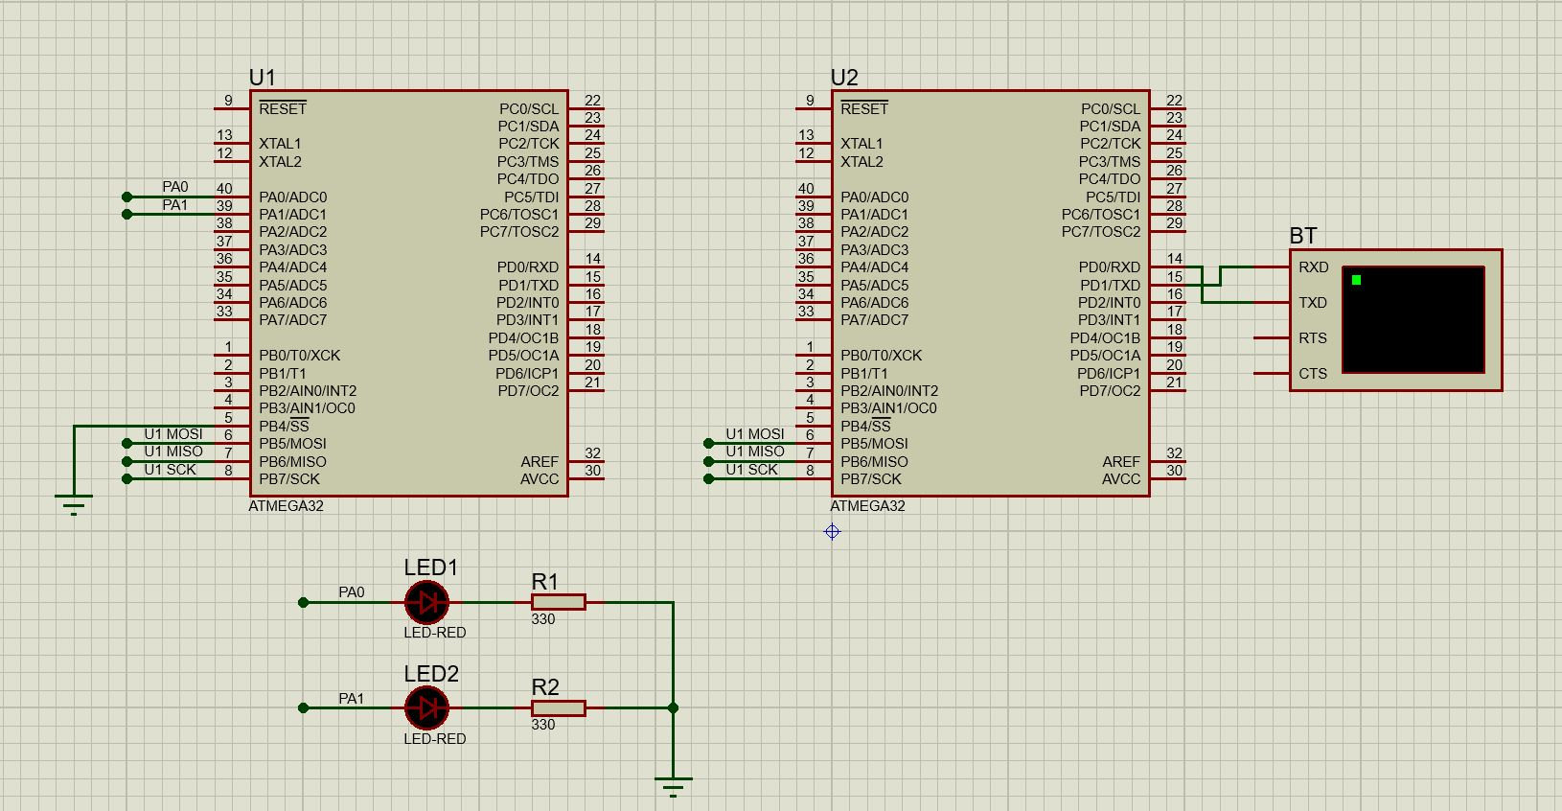

Procedures:

BT is our Bluetooth module which we send data to using our mobile phone and then the BT communicates with U2 microcontroller via USART communication protocol, then U2 resends the data he got from the BT to U1 microcontroller using SPI communication protocol and last U1 controls the LEDS 1 and 2 depending on the command he gets from U2.

In conclusion we control the LEDS using out mobile phone remotely via Bluetooth.

These are the options we can use in the simulation to demonstrate its functionality:

Sending 1 will toggle led1.

Sending 2 will toggle led2.

Sending 3 will turn on both leds.

Sending 4 will turn off both leds.

And these options can be changed later depending on what the Bluetooth app sends and the actuators we use in our system.